Playing with Managed Identities (25’)

In this exercise, you have an Azure web app, which should be able to pull a secret from Key Vault. You must respect the following constraint:
- The webapp must authenticate against the Key Vault with its managed identity
To achieve this, you’ll need the following components:
- Azure Web App
- Azure Key Vault
- System-Assigned or User-Assigned Identity
- Azure Key Vault References
To test whether the web app is able to pull the secret from Key Vault, use Key Vault References from the web app. If everything is fine, you should see something similar to this in the source column of the web app’s environment variables:

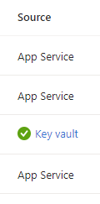

Else, if you missed anything, you’d rather see something like this:
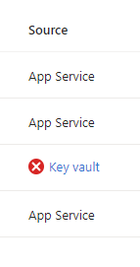

Tips:
- Make sure to grant access to Key Vault.

